
King Abdulaziz University
Faculty of Computing and Information Technology
Professional Master in Artificial Intelligence

Midterm Report

Project Title: SmartClaim AI Agent
Prepared by: Ra’ana Hatim Shaikh
Supervised by: Dr. Somayah albaradei

Contents
0.1 Introduction 2
0.2 Literature Review 2
0.3 Methodology 2
0.4 References 2

Introduction
Insurance companies face ongoing challenges in processing claims efficiently, as manual procedures and traditional processes lead to noticeable delays in completing requests. This directly impacts customer satisfaction and the quality of services provided, especially when dealing with accident reports that require careful analysis to estimate the extent of damages and their costs. Despite technological advancements, there is still a need for smarter solutions that help accelerate these processes and improve their accuracy, which highlights the problem background and its importance in the insurance sector. This project aims to develop an intelligent system based on artificial intelligence technologies to improve the efficiency of insurance claims processing. The system allows the affected individual to benefit from the “Najm” report by analyzing the accident description and providing an approximate estimate of vehicle damage costs quickly and reliably. It also helps the user understand how to submit a claim to the appropriate insurance company. The project scope includes the use of Microsoft Agent to present a detailed view of the case, including the fault percentage, its causes, the date and location of the accident, in addition to its description, which enhances clarity of information and accuracy in decision making. The importance of this project lies in its contribution to reducing claim processing time and improving the operational efficiency of insurance companies, as well as enhancing customer experience by providing fast and accurate services. It also supports digital transformation in the insurance sector by employing machine learning models capable of analysis and generalization, enabling them to handle new cases efficiently and deliver more reliable results, which reflects the project’s value and impact in advancing this field.

0.2 Literature Review
1. Overview of Related Work:
Previous studies in artificial intelligence emphasize that machine learning models are built through structured stages: training, validation, and testing to ensure performance and generalization. According to Artificial Intelligence: A Modern Approach, these stages enable models to learn patterns and apply them to unseen data. In the training phase, the model learns the relationship between inputs (accident descriptions) and outputs (damage costs). This is followed by validation to fine-tune performance and ensure accuracy. Finally, testing evaluates the model using unseen data to measure generalization. Advancements in deep learning, as discussed in Deep Learning, have improved prediction accuracy in complex domains like insurance claims. Additionally, Natural Language Processing (NLP), highlighted in Speech and Language Processing, is used to extract insights from accident reports. These techniques help automate claim analysis, improve accuracy, and speed up processing.

2. Research Gaps:
Despite their effectiveness, many models focus only on prediction without integrating into a complete insurance system. They may also struggle with generalization on new data. Existing solutions often lack a direct link between analyzing accident descriptions, estimating costs, and routing claims to the appropriate company. They also do not provide key insights such as fault percentage and accident causes. This project addresses these gaps by developing an integrated system combining training, validation, and testing with practical application. It analyzes “Najm” reports, predicts costs, clarifies accident details, and directs claims intelligently, improving accuracy, efficiency, and generalization.

3. Comparison with Previous Work:
Previous studies in the field of artificial intelligence indicate that many existing systems primarily focus on predicting damage costs using machine learning models without fully integrating the complete insurance claim processing workflow. In addition, these systems often lack a direct connection between accident analysis, claim routing, and decision support, which limits their overall effectiveness. In contrast, the proposed SmartClaim AI Agent provides a more comprehensive and integrated solution by combining multiple functionalities within a single system. It not only focuses on predicting damage costs, but also analyzes accident reports using Natural Language Processing (NLP) techniques, extracts important information such as fault percentage and accident causes, and intelligently routes claims to the appropriate insurance company.

Furthermore, unlike traditional models that mainly rely on data patterns, the proposed system enhances user interaction through Microsoft Agent by providing clear and structured outputs that support better decision-making.

0.3 Methodology
The project adopts a machine learning based approach combined with intelligent agent systems to automate insurance claim processing. The methodology includes training models to analyze accident descriptions and predict damage costs, in addition to applying Natural Language Processing (NLP) techniques to extract important information from accident report texts such as “Najm” reports. Microsoft intelligent technologies (Microsoft Agent) are also used to present detailed information such as fault percentage, causes of the accident, and other related data. The system further incorporates automation techniques to classify claims, verify document completeness, and intelligently route claims to the appropriate insurance company, which reduces human intervention and improves overall efficiency. The project relies on datasets that include accident reports, “Najm” reports, customer information, and supporting documents, which are used for training, validation, and testing the models. Preprocessing steps include cleaning the text data, removing irrelevant or duplicate information, standardizing text formats, and organizing the data to make it suitable for analysis. In addition, feature extraction techniques are used to convert textual accident descriptions into numerical representations that the model can process. The data is also divided into training, validation, and testing sets to ensure accurate evaluation of the model’s ability to generalize.

Step | Stage | Description
1 | Data Collection | Collect accident reports, “Najm” data, and related documents.
2 | Data Preprocessing | Clean data, remove duplicates, handle missing values, and standardize text.
3 | Feature Extraction | Convert accident descriptions into numerical features using NLP.
4 | Model Training | Train models to map accident descriptions to damage costs.
5 | Model Validation | Evaluate and fine-tune the model to reduce overfitting.
6 | Model Testing | Test performance on unseen data to ensure generalization.
7 | Accident Analysis | Analyze key details (fault, cause, location, date).
8 | Cost Estimation | Predict approximate damage costs.
9 | Claim Classification | Classify claims by type and severity.
10 | Claim Routing | Route claims to the appropriate insurance company.
11 | Result Presentation | Present results via Microsoft Agent with a report.

0.4 Results and Discussion
The proposed SmartClaim AI Agent system demonstrated effective performance in automating insurance claim processing. The machine learning model was able to analyze accident descriptions from “Najm” reports and generate reasonably accurate estimates of vehicle damage costs.

The system showed strong capability in extracting key information from textual data using NLP techniques, including accident details, fault percentage, causes of the accident, and other relevant attributes. This contributed to improving the clarity and completeness of claim information. Additionally, the integration of Microsoft Agent enhanced user interaction by presenting structured and understandable outputs, which supports better decision-making. The system was also able to classify claims and route them to the appropriate insurance company efficiently, reducing manual intervention.
The overall system achieved improvements in:
1-Reducing claim processing time
2-Increasing accuracy of cost estimation
3-Enhancing user experience through automation
4-Improving the ability to generalize to new accident cases
These results indicate that the proposed solution successfully addresses the limitations of traditional systems by providing an intelligent, integrated, and efficient insurance claim processing framework.
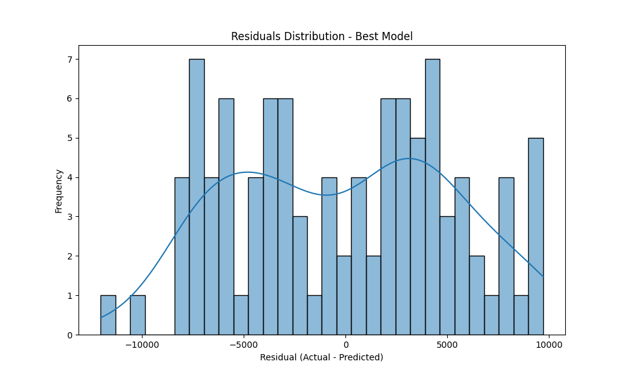

0.5 References

- Insurance Authority – Kingdom of Saudi Arabia. Home Page. Available at: https://www.ia.gov.sa/ (accessed on [insert date]).
- Najm for Insurance Services – Kingdom of Saudi Arabia. Official Website. Available at: https://www.najm.sa/ (accessed on [insert date]).

- Taqdeer – Integrated Vehicle Damage Assessment System. Official Website. Available at: https://taqdeer.sa/ (accessed on [insert date]).
- Russell, S., & Norvig, P. (2020). Artificial Intelligence: A Modern Approach (4th Edition). Pearson. – For artificial intelligence, classification models, and rule-based systems.

- Goodfellow, I., Bengio, Y., & Courville, A. (2016). Deep Learning. MIT Press. – For deep learning techniques used in computer vision and data analysis.

- Jurafsky, D., & Martin, J. H. (2023). Speech and Language Processing (3rd Edition Draft). – For natural language processing (NLP) to analyze accident reports and Najm report texts.

- Szeliski, R. (2010). Computer Vision: Algorithms and Applications. Springer. – For computer vision techniques and extracting information from accident images.

- Pressman, R. S., & Maxim, B. R. (2019). Software Engineering: A Practitioner’s Approach. McGraw-Hill. – For requirements analysis, system design, and module integration.

- Microsoft Docs — Azure Cognitive Services (OCR, Vision, NLP, LUIS). – For using Microsoft intelligent technologies to analyze data, generate reports, and link claims digitally.

- FastAPI Documentation — tiangolo.github.io/fastapi and Django Documentation — docs.djangoproject.com – For developing system interfaces and connecting different modules.

